Lab: R in DSX

November 30th, 2017

Author: Elena Lowery elowery@us.ibm.com
Table of contents
Overview 1
Required software, access, and files 1
Part 1: Create a DSX Project and run R notebook and Shiny 1
Part 2: Publish Shiny 3
Part 3: Check Status of Shiny Server 4

Overview
In this lab you will work with various R assets in DSX Local.

Required software, access, and files

- To complete this lab, you will need access to a DSX Local cluster.
- You will also need to download and unzip this GitHub repository: https://github.com/elenalowery/DSX_Local_Workshop

Part 1: Create a DSX Project and run R notebook and Shiny

- Log in to a DSX Local cluster.

- Navigate to the downloaded GitHub project. Navigate to the DSX Local Projects folder and rename DS_for_Automotive.zip to a unique name (for example, add your initials).

- Create a project “from file”.

- Switch to the Assets tab. Open DriverClassification notebook.

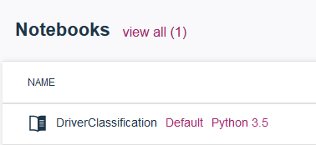

- Work through the notebook.

Note: notice that in the notebook we save the model into the RStudio directory. We use this approach because when we open RStudio, the model is displayed in the UI, which makes it easier for integration with the Shiny application.

In the sample notebook we overwrite the file each time we run the “save code”, but additional code can be added to add a version number to the model name.

At this time DSX doesn’t provide any additional “model management features” for R models.

- Open RStudio from the Project view.

- If serverR file is not already loaded in the top left window, click on the demoBreakEvents folder in the file explorer (right bottom window), then click on serverR.

After the application is loaded, click the Run App button.

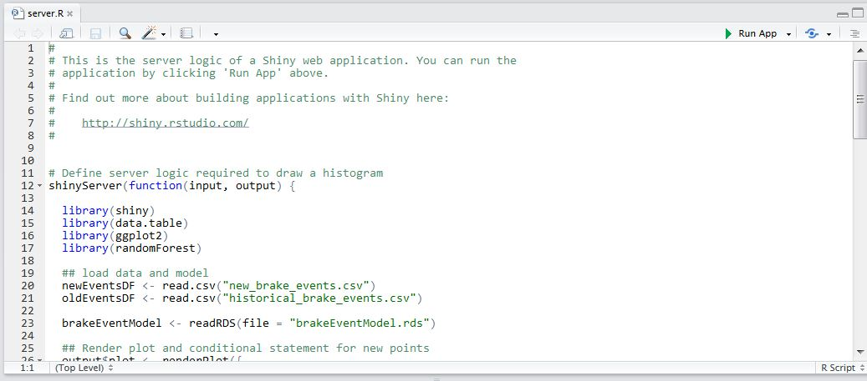

- Select Allow popups to bring up the application. Test the application - both the Explore and Model tabs.

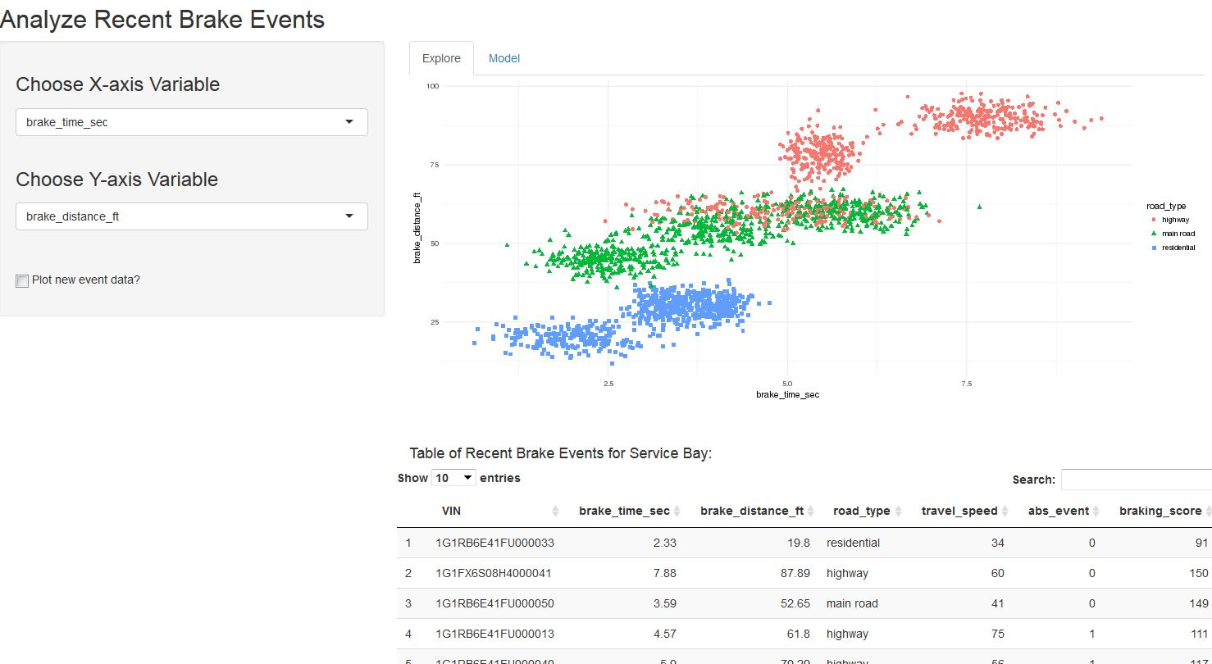

Part 2: Publish Shiny

In this section we will publish the Shiny application.

- Navigate back to the Project view and click Preview from the ellipses next to the Shiny application (demoBreakEvents).

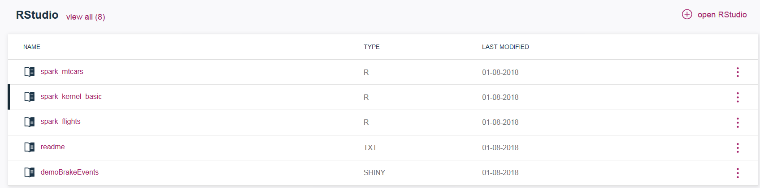

- If you get an error during preview, check with the lab instructor.

- From the same menu click Publish. Provide Published name (try to make it unique, for example, add your initials) and select Published content visibility that you would like to test. Click Publish.

Note: All Shiny applications in DSX are published to a shared Shiny server. At this time there is only 1 instance of the Shiny server in DSX (i.e. it’s not configured for HA). However, because the Shiny server is deployed as a pod, Kubernetes will monitor its status and restart it, when needed.

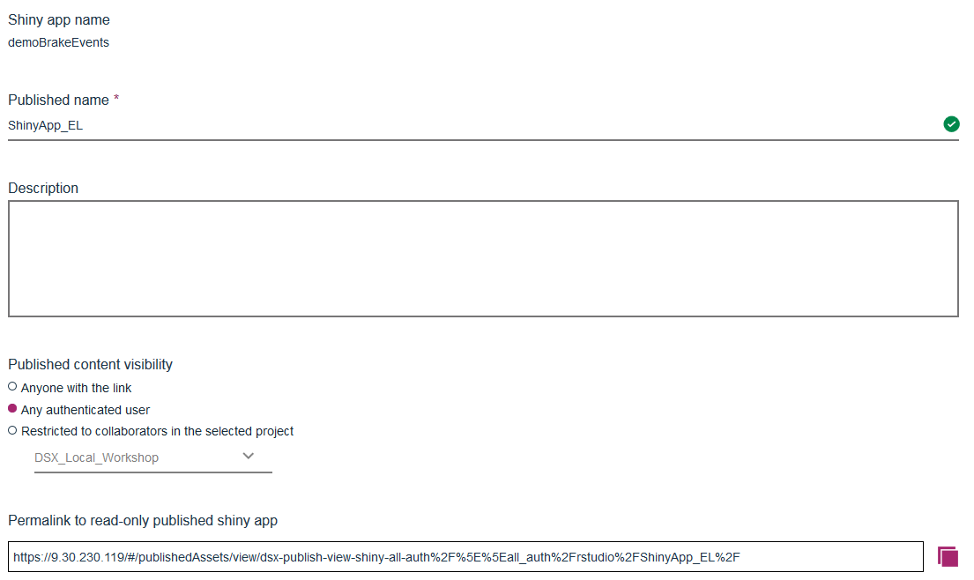

- Click on the status message (View) or navigate to Published Assets from the main DSX menu.



- Verify that the application works.

- Depending on the “scope” that you published to, the Shiny application can be accessed through different views in DSX.

  - If selected anyone with the link or any authenticated user, then you can view it in the Published Assets accessed through the main DSX menu (in the top left corner)

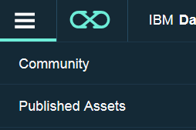

  - If you published it to a specific project, then it will show up in the Published Assets tab of the project you published to (not published from).

Part 3: Check Status of Shiny Server

At this time the Shiny Server is deployed as a pod in DSX, and the only way to view status is by looking at the status of the pod. You must have admin privileges to perform these functions.

There is only 1 instance of Shiny Server, but Kubernetes monitors pod status, and the pod should be automatically restarted if it goes down.

- Switch to the IBM Data Platform Manager view

- Click on Pods. Scroll down to locate the r-publish… pod. This is the Shiny Server.

- If the pod is not running, you can redeploy it from this UI or via Kubernetes commands in ssh.

Display all pods: kubectl get pods --all-namespaces

Delete pod: kubectl delete pod <pod name> -n <namespace>

Force delete for a pod (if it’s stuck in “terminating” state):
kubectl delete pod <pod name> -n <namespace> --grace-period=0

